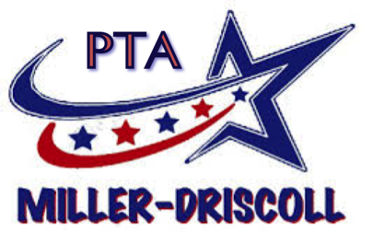
Gifts and Grants Proposal Application

Please complete and return this form in full to Danielle Dooner at giftsandgrants@millerdriscollpta.org or drop it in the PTA Gifts and Grants mailbox. Contact 203-914-9502 with any questions.

You must be a member of the Miller-Driscoll PTA to submit an application.
Are you a member? ☐

Name:

Best way to contact you:

School + Position:

Amount requested in this application? (Include all costs, including price, shipping, handling, etc. If using estimates, please provide the source.)

Describe the project or item for which funding is requested. (Be specific. Include manufacturer/vendor name, phone number, email address, item number(s) and full description. Provide documentation or brochures, if available.)

(Cont. on pg. 2)

Grant Proposal Application, pg. 2

Project description (cont.):

How will this enrich the existing curriculum or enhance the students' learning experience? How many students will benefit?
Have you requested funds from another source? What is the status?

