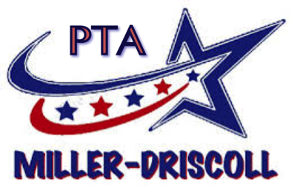
Gifts and Grants Guidelines

- Individuals, teachers and parents submitting the grant requests must be members in good standing of the PTA in order to apply for a grant.
- Grant approval will be based on the objective, anticipated benefits, number of students involved, and the Committee’s confidence in the success of the project.
- Grant requests are limited to projects with educational/instructional merit.
- Funding for projects or equipment included in the BoE budget will generally NOT be considered.
- Funding for furniture items will generally NOT be considered.
- Funding for repeat projects will generally NOT be considered within 3 years of the initial grant. Such projects must be included in the Miller-Driscoll PTA budget.
- Grant requests will be judged on the innovative nature of the project and the extent to which the project will improve the existing methods of instruction.
- The grant committee will take into consideration the longevity of the program as well as the ability to duplicate the program in other classrooms.
- Applications must include ALL costs, including shipping, handling, and taxes, to the extent that information is available. Estimates must be substantiated.
- Monies cannot be disbursed without a purchase order, paid receipt or invoice.
- Materials purchased with grant funds become the property of the Miller-Driscoll School and must remain at the school should the teacher/recipient leave the school.
- All grants must be in compliance with the school district guidelines and PTA objectives.

Submission Process:

- Applications for funding will be accepted from any member of the school community, including parents. Applicant must be a member of the Miller-Driscoll PTA.
- Applications must be fully completed. Incomplete applications will be returned.
- Anything over $25,000 must be submitted and approved of by the BoE.
- After the committee has reviewed the submission, the request will be put forth to the PTA membership and posted on the PTA website. The following meeting the request will be voted on.
- Grants will only be approved if there are available funds in the budget. If the PTA wishes to support the grant, the PTA can postpone voting on the grant and fundraise to fund the grant.

Committee:

Grant committee will work with the executive committee to make sure all rules are followed and make recommendations for the gifts and grants. The recommendation will be presented to the general PTA and the submission process will be followed.

